Hands-on 1: jQuery

<!DOCTYPE html>

<html>

<head>

<script src="https://ajax.googleapis.com/ajax/libs/jquery/3.6.4/jquery.min.js"></script>

<script>

$(document).ready(function(){

$("p").click(function(){

$(this).hide();

});

});

</script>

</head>

<body>

<p>If you click on me, I will disappear.</p>

<p>Click me away!</p>

<p>Click me too!</p>

</body>

</html>

OUTPUT:

If you click on me, I will disappear.

Click me away!

Click me too!

Hands-on 2: Jquery Element Selector

<!DOCTYPE html>

<html>

<head>

<script src="https://ajax.googleapis.com/ajax/libs/jquery/3.6.4/jquery.min.js"></script>

<script>

$(document).ready(function(){

$("button").click(function(){

$("p").hide();

});

});

</script>

</head>

<body>

<h2>This is a heading</h2>

<p>This is a paragraph.</p>

<p>This is another paragraph.</p>

<button>Click me to hide paragraphs</button>

</body>

</html>

OUTPUT:

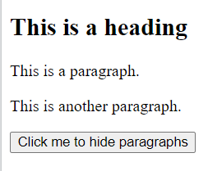

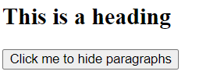

Hands-on 3: Jquery ID Selector

<!DOCTYPE html>

<html>

<head>

<script src="https://ajax.googleapis.com/ajax/libs/jquery/3.6.4/jquery.min.js"></script>

<script>

$(document).ready(function(){

$("button").click(function(){

$("#test").hide();

});

});

</script>

</head>

<body>

<h2>This is a heading</h2>

<p>This is a paragraph.</p>

<p id="test">This is another paragraph.</p>

<button>Click me</button>

</body>

</html>

OUTPUT:





Hands-on 4: Jquery Class selector

<!DOCTYPE html>

<html>

<head>

<script src="https://ajax.googleapis.com/ajax/libs/jquery/3.6.4/jquery.min.js"></script>

<script>

$(document).ready(function(){

$("button").click(function(){

$(".test").hide();

});

});

</script>

</head>

<body>

<h2 class="test">This is a heading</h2>

<p class="test">This is a paragraph.</p>

<p>This is another paragraph.</p>

<button>Click me</button>

</body>

</html>

OUTPUT:





Hands-on 5: Jquery Event Methods

<!DOCTYPE html>

<html>

<head>

<script src="https://ajax.googleapis.com/ajax/libs/jquery/3.6.4/jquery.min.js"></script>

<script>

$(document).ready(function(){

$("#p1").mouseenter(function(){

alert("You entered p1!");

});

});

</script>

</head>

<body>

<p id="p1">Enter this paragraph.</p>

</body>

</html>

OUTPUT:

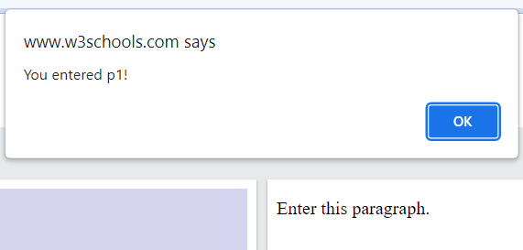

Hands-on 6: Jquery DOM Manipulation

<!DOCTYPE html>

<html>

<head>

<script src="https://ajax.googleapis.com/ajax/libs/jquery/1.11.2/jquery.min.js">

</script>

<script>

$(document).ready(function () {

$('#div1').after('<div style="background-color:yellow"> New div </div>');

});

</script>

<style>

div{

border: 1px solid;

background-color:red;

margin: 2px 0 2px 0;

}

</style>

</head>

<body>

<h1>Demo: jQuery after() method </h1>

<div id="div1">div 1

</div>

<div id="div2">div 2

</div>

</body>

</html>

OUTPUT:

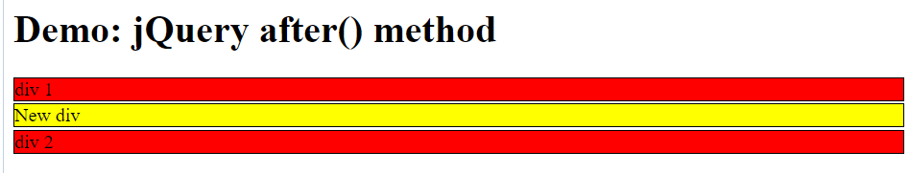

Hands-on 7: Jquery Effects

<!DOCTYPE html>

<html>

<head>

<script src=

"https://ajax.googleapis.com/ajax/libs/jquery/3.3.1/jquery.min.js">

</script>

<title>

fadeIn() Method in jQuery

</title>

<style>

#Outer {

border: 1px solid black;

padding-top: 40px;

height: 140px;

background: green;

display: none;

}

</style>

</head>

<body style="text-align:center;">

<div id="Outer">

<h1 style="color:white;">

EDUNETFOUNDATION

</h1>

</div><br>

<button id="btn">

Fade In

</button>

<!-- jQuery script of fadeIn() method -->

<script>

$(document).ready(function () {

$("#btn").click(function () {

$("#Outer").fadeIn(1000);

});

});

</script>

</body>

</html>

OUTPUT:

Hands-on 8: Jquery Animate

EDUNETFOUNDATION

<!DOCTYPE html>

<html>

<head>

<script src="https://ajax.googleapis.com/ajax/libs/jquery/1.11.2/jquery.min.js">

</script>

<script>

$(document).ready(function () {

$('#myDiv').animate({

height: '200px',

width: '200px'

});

});

</script>

<style>

.redDiv {

background-color: red;

height: 100px;

width: 100px;

}

</style>

</head>

<body>

<h1>Demo: jQuery animate() method</h1>

<div id="myDiv" class="redDiv">

</div>

</body>

</html>

OUTPUT:

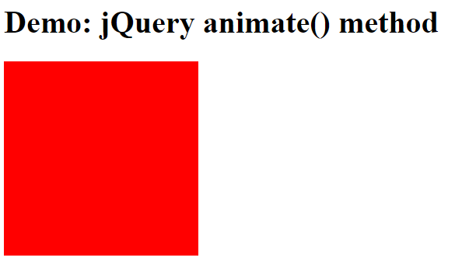

Hands-on 9: Jquery Parents()

<!DOCTYPE html>

<html>

<head>

<style>

.main_body * {

display: block;

border: 2px solid green;

color: green;

padding: 5px;

margin: 15px;

}

</style>

<script src=

"https://ajax.googleapis.com/ajax/libs/jquery/3.3.1/jquery.min.js">

</script>

<script>

$(document).ready(function () {

$("span").parents().css({

"color": "green",

"border": "2px solid green"

});

});

</script>

</head>

<body class="main_body">

<div style="width:500px;">

This is the great grand parent of the selected span element.!

<ul>

This is the grand parent of the selected span element.!

<li>

This is the parent of the selected element.!

<span>

This is the selected span element.!

</span>

</li>

</ul>

</div>

</body>

</html>

OUTPUT:

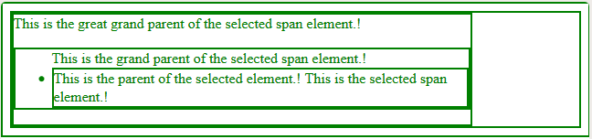

Hands-on 10: Jquery JSON method

<!DOCTYPE html>

<html>

<head>

<title>jQuery getJSON() Method</title>

<script src=

"https://ajax.googleapis.com/ajax/libs/jquery/3.3.1/jquery.min.js">

</script>

<!-- Script to get JSON file and display its content -->

<script type="text/javascript" language="javascript">

$(document).ready(function () {

$("#fetch").click(function (event) {

$.getJSON('employee.json', function (emp) {

$('#display').html('<p> Name: ' + emp.name + '</p>');

$('#display').append('<p>Age : ' + emp.age + '</p>');

$('#display').append('<p> Role: ' + emp.role + '</p>');

});

});

});

</script>

</head>

<body>

<p> Click on the button to fetch employee data </p>

<div id="display"

style="background-color:#39B54A;">

</div>

<input type="button"

id="fetch"

value="Fetch Employee Data" />

</body>

</html>

Employee.json

Name: Ram

Age: 25

Role: technical writer

OUTPUT:

Name: Ram

Age: 25

Role: technical writer

Hands-on: JQuery Ajax

<!DOCTYPE html>

<html>

<head>

<meta name="viewport" content="width=device-width" />

<script type="text/javascript"

src="https://ajax.googleapis.com/ajax/libs/jquery/1.11.2/jquery.min.js">

</script>

<script type="text/javascript">

$(document).ready(function () {

$('#ajaxBtn').click(function(){

$.ajax('/jquery/getdata', // request url

{

success: function (data, status, xhr) { // success callback function

$('p').append(data);

}

});

});

});

</script>

</head>

<body>

<h1> jQuery ajax() demo

</h1>

<input type="button" id="ajaxBtn" value="Send Ajax request" />

<p>

</p>

</body>

</html>

OUTPUT:

